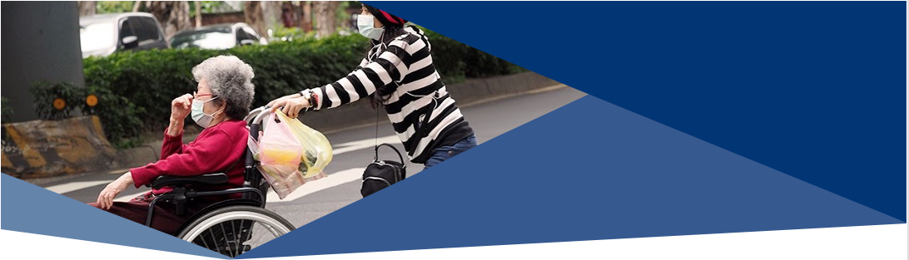
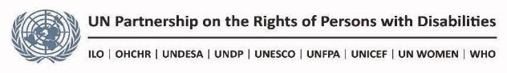

DISABILITY INCLUSIVE SOCIAL PROTECTION RESPONSE TO COVID-19 CRISIS

In regular circumstances, persons with disabilities, which comprise 15% of the world’s population, are more likely to be poor, to face catastrophic health expenditures, to have lower levels of education and economic participation and to live in households that are more exposed to economic insecurity and shocks.
Those inequalities, heightened for women and girls with disabilities, arise from multiple barriers faced at all ages, such as stigma, inaccessibility to infrastructures, transports and information systems as well as the lack of inclusive public policies and services. Those barriers generate significant disability related extra costs for persons with disabilities and their families, increasing their vulnerabilities.
The COVID-19 pandemic and its related socio-economic consequences magnify those obstacles and inequalities. Persons with disabilities are in many ways more exposed to the crisis:
- Many have underlying health conditions and/or are older persons which put them at greater risk requiring strict confinement.
- Many are facing significant disruption of their usual support system, especially children with disabilities and adults with high support requirements. The vast majority relying on informal and unpaid family support might be in a difficult situation as they or their usual support persons get contaminated or are at risk. Those who are using paid support or residential settings may face failure of service providers.
- Persons with disabilities are much less protected by social insurance (including unemployment and sickness) and health insurance, due to discrimination, exclusion from work or being active in the informal economy.
In any case, persons with disabilities and their families face significant challenges in terms of income security and greater costs to secure the essential goods and services they need.
Social protection which, at any point in time, is critical for persons with disabilities has proven to be a crucial vector of relief in the recent weeks. This brief presents several elements that can help make the most of the social protection systems response to COVID-19 to support persons with disabilities.
In general:
- Ensuring that all public information, crisis response measures, health and social protection interventions are inclusive, accessible for all and do not discriminate against persons with disabilities.
- Coordinating with organizations of persons with disabilities, parents’ organizations and services providers to ensure maximum dissemination of information and outreach.
- Removing any financial barriers to access health care (co-payment, fees…).
- Minimizing risks of contamination of persons with disabilities across social protection delivery mechanisms, expanding mobile or online registration or payment points.

Identification and need assessments:
- Extending identification and registration of persons with disabilities, including use of different relevant data registries to facilitate provision of support.
- Carrying out needs assessment of persons with disabilities, with attention to children, women and girls with disabilities, persons with high support requirements and older persons.
Cash transfers
- Ensuring adequate paid sick leave, sickness benefits or other income support in cases of sickness, quarantine and self-isolation.
- Increasing the level of disability benefits, providing extra payments and/or advancing payments.
- Extending cash transfers to all persons with disabilities officially registered that may not be eligible under regular circumstances, regardless of their current work status.
- Automatically extend any soon-to-expire disability related entitlements.
- Providing disability top up to recipients of main social assistance schemes who are identified as having a disability (old age, child grant, poverty assistance) to cover disability costs.
- Provide financial assistance for persons who stop working to support or to prevent contamination of their family member(s) with disabilities and who are not covered by unemployment or sickness benefits.
In kind assistance and support services
- Ensuring development and continuity in access to quality care and support, including through financial assistance to service providers.
- Considering delivery of essential food and non-food items to persons with high support needs.
- Creating helpline and developing platforms that can help match persons with disabilities requiring support and those who can provide it.
Recovery
- Ensuring that economic recovery programs are inclusive of persons with disabilities and their families.
The COVID-19 crisis demonstrates the importance for all countries to develop and strengthen collectively financed, comprehensive, inclusive and permanent social-protection systems. Countries which have developed comprehensive disability registry, universal disability allowance and support services are in position to provide fast and reliable relief to children, working age adults and older persons with disabilities.
- Useful resources:
- Joint Statement on the Role of Social Protection in Responding to the COVID-19 Pandemic, Social Protection Inter-Agency Cooperation Board
- Social protection response to the COVID-19 crisis, International, Labor Organization,
- Disability considerations during the COVID-19 outbreak, World Health Organization, March 2020
- Key recommendations toward a disability inclusive COVID 19 response, International Disability Alliance
- COVID-19: Who is protecting the people with disabilities?, UN Special Rapporteur on the Rights of Persons with Disabilities
- Joint statement: Towards inclusive social protection system supporting full and effective participation of persons with disabilities, ILO-IDA (2019)
- Global social protection framework, UNICEF (2019)
- Leave no one behind: building inclusive social protection systems for persons with disabilities. Development Pathways (2019)
- Contact: Alex Cote alex.cote@inclusive-policy.org
- Brief prepared in the frame of the UNPRPD funded project on inclusive social protection for the empowerment of persons with disabilities implemented by ILO and UNICEF in close collaboration with the International Disability Alliance.

Mizunoya, S. and Mitra, S., 2013. Is there a disability gap in employment rates in developing countries?. World Development, 42,; World Bank, Inclusion International, Leonard Cheshire. (2019). Every learner matters: Unpacking the learning crisis for children with disabilities .; WHO and World Bank, 2011, World report on disability (Geneva);
Mitra, S. ,2018, Disability, health and human development. Disability, Health and Human Development, Palgrave MacMillan: New York.
WHO-World bank, ibid ; UN DESA, 2018, Disability and Development Report:
Mitra, S. and al 2017. Extra costs of living with a disability: A review and agenda for research. Disability and health journal, 10(4), pp.475-484.
World Health Organisation, March 2020, Disability considerations during the COVID-19 outbreak
Mitra, S. and Kruse, D., 2016. Are workers with disabilities more likely to be displaced?. The International Journal of Human Resource Management, 27(14), pp.1550-1579.
Social Protection is defined as the set of policies and programs aimed at preventing or protecting all people against poverty, vulnerability, social exclusion throughout their lifecycles, placing a particular emphasis on vulnerable groups. Social protection can be provided in cash or in-kind; through non-contributory schemes, such as providing universal, categorical, or poverty targeted benefits; contributory schemes, and by building human capital and access to jobs (SPIAC-B).
ILO, 2017, World Social Protection Report 2017–19;
Joint Statement on the Role of Social Protection in Responding to the COVID-19 Pandemic, SPIAC-B
ILO, COVID-19: Social protection systems failing vulnerable groups.

